KARPAGA VINAYAGA

COLLEGE OF ENGINEERING AND TECHNOLOGY

Chinna Kolambakkam, Madhurantakam Tk, 603308



O

DEPARTMENT OF

ARTIFICIAL INTELLIGENCE AND DATA SCIENCE

CCS371

VIDEO CREATION AND EDITING LABORATORY



NAME REGISTER NO : BRANCH

SEM/YEAR

|  |  |  |  |  |
| --- | --- | --- | --- | --- |
| **SNO** | **DATE** | **TITLE** | **PAGE NO** | **SIGN** |
| **1** |  | Write a Movie Synopsis (Individual/Team Writing) |  |  |
| **2** |  | Present team stories in class. |  |  |
| **3** |  | Script/Storyboard Writing(Individual Assignment) |  |  |
| **4** |  | Pre-Production:Personnel, budgeting, scheduling, location scouting, casting, contracts & agreements |  |  |
| **5** |  | Production: Single camera production personnel & equipment, Documentary  Production |  |  |
| **6** |  | Writing The Final Proposal: Overview, Media Treatments, Summary, Pitching |  |  |
| **7** |  | Write Documentary  & AnimationTreatment |  |  |
| **8** |  | Post-production:Editing,Sound design,Finishing |  |  |

**EX NO : 1**

**1. Write a Movie Synopsis (Individual/Team Writing)**

**DATE :**

## Aim :

To develop skills in crafting a compelling movie synopsis that outlines the key elements plot, characters, and themes.

## Materials:

* Pen and paper or computer for writing
* Reference materials (optional)

## Procedure:

1. Choose a movie concept or idea to develop into a synopsis.
2. Identify the main characters, setting, conflict, and resolution of the story.
3. Write a concise summary that captures the essence of the film in a few paragraphs.
4. Revise and refine the synopsis to ensure clarity, coherence, and engaging storytelling.

## Observations:

* The synopsis should provide an overview of the plot without revealing all the details.
* Effective synopses convey the tone, genre, and central themes of the movie.
* Feedback from peers or instructors can help improve the quality of the synopsis.

## Synopsis:

**Title: “ Unbreakable Sisters”**

In the bustling city of New York, five women from diverse backgrounds find their lives intersecting in unexpected ways, bound together by their shared struggles and aspirations.

Maya, a tenacious investigative journalist, is on a mission to expose corruption within the city's political circles. As she delves deeper into her investigation, she faces threats to her career and personal safety but refuses to back down, driven by her commitment to justice and truth.

Sarah, a resilient single mother, dreams of building a better life for her daughter despite facing numerous obstacles. With unwavering determination, she launches her own business, navigating the challenges of entrepreneurship while challenging societal norms and stereotypes.

Aisha, a talented and fiercely independent artist, confronts skepticism and prejudice in the male-dominated art world as she strives to showcase her unique vision and voice. With the support of her fellow sisters, she finds the courage to embrace her identity and pursue her passion unapologetically.

Elena, a compassionate and dedicated nurse, battles against discrimination and bias within the healthcare system as she cares for her patients with empathy and integrity. Despite facing resistance from colleagues and superiors, she remains steadfast in her commitment to providing quality care to those in need.

Grace, a determined and principled lawyer, fights tirelessly for justice, advocating for victims of abuse and exploitation. As she navigates the complexities of the legal system, she confronts her own past traumas and insecurities, finding strength and resilience in the bond she shares with her fellow sisters.

As their paths converge, these five women form a sisterhood of support and solidarity, drawing strength from each other as they confront the challenges and injustices they face. Through their collective resilience, courage, and unwavering spirit, they inspire change, empower others, and prove that together, they are truly unbreakable.

Against the backdrop of their individual journeys, "Unbreakable Sisters" is a celebration of the resilience, courage, and unwavering spirit of women as they rise above adversity to claim their place in a world that often seeks to silence them.

## Result:

Writing a movie synopsis requires careful consideration of storytelling elements to hook the audience and generate interest in the film was successfully done.

**EX NO : 2**

**2. Present team stories in class.**

**DATE :**

## Aim:

To practice effective communication and presentation skills by sharing team stories with classmates.

## Materials:

* Presentation slides or visual aids (optional)
* Speaking notes or script

## Procedure:

1. Choose a team project or experience to present to the class.
2. Structure the presentation with an introduction, main points, and conclusion.
3. Use visuals, anecdotes, and data to enhance the storytelling and engagement.
4. Practice delivering the presentation with confidence and clarity.
5. Encourage audience interaction and feedback during or after the presentation.

## Observations:

* Effective presentations capture the audience's attention and convey key messages clearly.
* Engaging storytelling techniques, such as using personal experiences or visuals, can enhance the presentation.
* Feedback from peers and instructors can help improve presentation skills.
* When presenting team stories in class, it's essential to engage your audience and effectively convey the key points of your team's journey. Here's a structured approach to presenting team stories:

## Introduction:

Start by introducing your team and the purpose of your presentation. Provide a brief overview of the project or experience your team worked on. **Context and Background:**

Share the background information related to your team's story, including the project's objectives, challenges, and timeline.

Explain the roles and responsibilities of team members and how they contributed to the project's success.

## Journey and Challenges:

Describe the journey your team embarked on, highlighting significant milestones, achievements, and obstacles faced along the way.

Share specific challenges your team encountered and how you overcame them through collaboration and problem-solving.

## Key Learnings:

Discuss the lessons learned from the project or experience, including skills gained, insights gained, and areas for improvement.

Reflect on how the team's collaboration, communication, and teamwork contributed to the overall outcomes.

## Results and Impact:

Present the results or outcomes of your project, showcasing any tangible deliverables, achievements, or successes.

Discuss the impact of your team's work, both internally (team dynamics, personal growth) and externally (impact on stakeholders, community).

## Future Plans:

Share any future plans, continuation of the project, or potential areas for further development based on your team's experience and learnings.

## Q&A Session:

Invite questions from the audience to encourage engagement and clarify any aspects of your team's story.

Be prepared to provide detailed answers and insights based on your team's experience.

## Closing Remarks:

Conclude your presentation with a summary of key points and a thank-you message to the audience for their attention and participation.

Express gratitude to team members, mentors, or stakeholders who supported your team throughout the journey.

## Story of Two Friends - Monkey and the Elephant in a Jungle

In the bustling city of New York, five women from diverse backgrounds find their lives intersecting in unexpected ways, bound together by their shared struggles and aspirations.

Maya, Sarah, Aisha, Rlena, Grace

Maya, a determined journalist with a fiery passion for uncovering the truth, found herself embroiled in a high-stakes investigation exposing corruption within the city's political elite. Despite facing threats and intimidation, Maya refused to waver, driven by her unwavering commitment to justice.

Sarah, a single mother and aspiring entrepreneur, navigated the challenges of raising her daughter while pursuing her dream of starting her own business. With sheer determination and resilience, Sarah overcame countless obstacles, proving that nothing could stand in the way of her ambition.

Aisha, a talented artist with a rebellious spirit, defied societal expectations as she fought to carve out her place in the male-dominated art world. Through her bold and unapologetic expression, Aisha challenged stereotypes and shattered barriers, inspiring others to embrace their authentic selves.

Elena, a compassionate nurse dedicated to healing others, faced discrimination and bias within the healthcare system. Yet, her unwavering empathy and unwavering dedication to her patients remained unshakeable, earning her the respect and admiration of her peers.

Grace, a principled lawyer with a fierce sense of justice, fought tirelessly for the rights of the marginalized and oppressed. With her sharp intellect and unwavering integrity, Grace became a beacon of hope for those seeking legal recourse against injustice.

As their individual journeys unfolded, these five women found solace and strength in each other's company, forming a sisterhood bound by shared experiences and unwavering support. Through the trials and tribulations they faced, they discovered the true power of unity and solidarity.

When Maya's investigation threatened to expose dangerous truths, Sarah provided her with shelter and support, offering a safe haven for Maya to continue her pursuit of justice. In turn, Maya's relentless determination inspired Sarah to persevere in the face of adversity, fueling her entrepreneurial aspirations.

Aisha's bold artistic expression sparked a movement of empowerment and self-acceptance, drawing inspiration from the resilience of her sisters. Elena's compassionate care and Grace's unwavering advocacy served as reminders of the importance of fighting for what is right, no matter the cost.

Together, these unbreakable sisters defied expectations, shattered stereotypes, and emerged stronger and more empowered than ever before. Through their unwavering solidarity and unyielding determination, they proved that when women support each other, there is no limit to what they can achieve.

**The moral of "The Bond of Unbreakable Sisters" is that strength, resilience, and empowerment are amplified when women support and uplift each other. Through their solidarity and unwavering determination, the sisters demonstrate the power of unity in overcoming adversity and achieving their goals. The story underscores the importance of standing together, embracing individuality, and fighting for justice and equality, inspiring others to cultivate supportive communities and champion the rights and aspirations of all women.**

**RESULT:**

Presenting team stories in class provides valuable practice in public speaking, storytelling, and communication strategies was successfully done.

**EX NO : 3**

**3.Script/Storyboard Writing(Individual Assignment)**

**DATE :**

## Aim:

To develop skills in writing scripts and storyboards for visual media projects.

## Materials:

* Screenwriting software or template
* Storyboard template or paper
* Pen and paper or computer for writing

## Procedure:

1. Choose a concept or idea for a script or storyboard.
2. Outline the plot, characters, dialogue, and visual elements of the story.
3. Write a script using proper formatting and structure for screenplays.
4. Create a storyboard to visually represent scenes, camera angles, and transitions.
5. Revise and refine the script and storyboard based on feedback and creative insights.

## Observations:

* Scripts should follow industry-standard formatting and conventions.
* Storyboards help visualize the sequence of shots and guide the production process.
* Collaboration with team members and feedback from peers can improve the quality of scripts and storyboards.

## Script:

**Title: "The Enchanted Forest"**

Scene 1: Int. City Apartment - Day

We open to a bustling cityscape outside a window. Inside, we see the apartment shared by Maya, Sarah, Aisha, Elena, and Grace. They are gathered around the kitchen table, sharing breakfast.

**Maya**: (flipping through a newspaper) Did you see this article about the mayoral scandal?

**Sarah**: (pouring coffee) It's outrageous! We need to do something about it.

**Aisha**: (painting at the table) Maybe I can use my art to raise awareness.

**Elena**: (checking her phone) I'll reach out to some contacts at the hospital. We can't let this slide.

**Grace**: (putting on her blazer) And I'll start digging into the legal implications. We need to make sure justice is served.

**Scene 2: Ext. City Streets - Day**

We see quick shots of each sister going about her day, taking action in her respective field to address the scandal.

**Scene 3: Int. City Hall - Day**

The sisters convene outside City Hall, determined expressions on their faces.

**Maya**: This is it. Let's do this together.

**Sarah**: (nodding) Unbreakable sisters, always.

They link arms and enter City Hall together.

**Scene 4: Ext. City Hall Steps - Day**

The sisters emerge from City Hall, victorious smiles on their faces. The scandal has been exposed, and justice has been served.

**Aisha**: We did it!

**Elena:**(hugging Sarah) I'm so proud of us.

**Grace**: This is just the beginning. Together, we're unstoppable.

They stand together, a symbol of strength and unity, as the camera pans out to capture the city skyline.

Fade Out

**Storyboard:**

1. **Scene 1**:

Image: Apartment interior, sisters gathered around the kitchen table.

Action: Maya reading newspaper, Sarah pouring coffee, Aisha painting, Elena checking phone, Grace putting on blazer.

2. **Scene 2**:

Image: Quick shots of each sister in action (Maya interviewing, Sarah making phone calls, Aisha painting, Elena with patients, Grace in courtroom).

3. **Scene 3**:

Image: Sisters outside City Hall, determined expressions.

Action: Maya rallying the group, Sarah nodding in agreement, Aisha with paintbrush in hand, Elena checking her watch, Grace straightening her blazer.

4. **Scene 4**:

Image: Sisters emerging from City Hall, victorious.

Action: Aisha cheering, Elena hugging Sarah, Grace looking determined, Maya smiling confidently.

This script and storyboard capture the essence of the unbreakable bond shared by the sisters as they work together to address a scandal and uphold justice in their city.

## End Credits:

Roll credits with enchanting music playing in the background, showcasing key moments from the journey and highlighting the talented cast and crew who brought "The Unbreakable Sisters”

## Results:

Script and storyboard writing are essential skills for planning and executing visual media projects effectively.

**EX NO :**

**4. Pre-Production:**

**Personnel,**

**budgeting,**

**DATE:**

**scheduling, location scouting, casting, contracts &**

**agreements.**

## AIM:

To understand the key aspects of pre-production in media production, including personnel management, budgeting, scheduling, location scouting, casting, and contracts/agreements.

## Materials:

* Pre-production checklist or template
* Budgeting software or spreadsheet
* Casting resources and contracts/agreements templates
* Location scouting tools and resources

## Procedure:

1. Identify project personnel roles and responsibilities.
2. Create a budget that outlines expenses for personnel, equipment, locations, and other resources.
3. Develop a production schedule that includes timelines for pre- production, production, and post-production phases.
4. Conduct location scouting to suitable locations.
5. Cast actors and secure contracts/agreements for their involvement in the project.

## Observations:

* Effectively pre-production planning is crucial for a smooth production process.
* Budgeting and scheduling tools help manage resources and timelines.
* Clear communication and documentation are essential for casting and contract negotiations.

## Pre-Production Overview:

Pre-production, or "pre", is the phase of planning and execution that takes place before the actual shoot. It's a crucial stage that helps ensure that the project's vision, goals, and logistics align from the beginning. Pre-production typically includes:

Budgeting: Creating a budget that covers all expenses, including legal fees, insurance, and contingency funds

Story selection: Deciding on the story

Script creation: Writing the script and creating a script breakdown Hiring crew: Finding the right cast and crew

Location scouting: Ensuring the locations align with the script's requirements Set and costume design: Deciding on sets, costumes, and props

Rehearsals: Rehearsing with the actors

Shooting schedule: Finalizing the shooting schedule

Other pre-production tasks include: Wardrobe and prop design, Storyboarding, Pre-visualization, Pre-lighting, and Pre-composition.

Every project is depending on the budget and the size of the production, but there are some relatively universal guidelines to consider. For example, you should allocate about 10% to 15% of your total budget to pre- production.

Pre-production is a crucial phase in media production where the foundation for a successful project is laid. This phase involves various key elements such as personnel management, budgeting, scheduling, location scouting, casting, and contracts/agreements. Let's break down each of these components:

## Personnel Management:

Identify and assign roles and responsibilities to team members based on their expertise and skills.

Ensure clear communication channels and collaboration among teammembers.

Establish leadership roles such as producer, director, production manager, and department heads.

## Budgeting:

Create a detailed budget that includes all anticipated expenses for the project, including personnel salaries, equipment rentals, location fees, post-production costs, marketing, and contingencies.

Allocate funds based on priority areas and project requirements.

Monitor and track expenses throughout the production process to stay within budget.

## Scheduling:

Develop a production schedule that outlines the timeline for pre-production, production, and post-production phases.

Coordinate with department heads and key personnel to ensure smooth workflow and adherence to deadlines.

Anticipate potential scheduling and plan accordingly to mitigate risks.

## Location Scouting:

Conduct thorough location scouting to suitable locations that match the project's aesthetic and narrative requirements.

Consider factors such as accessibility, permits, permissions, and logistical considerations.

Document potential locations with photos, videos, and detailed notes for reference during production.

## Casting:

Hold auditions or casting calls to actors and performers who the roles in the script or project requirements.

Collaborate with casting directors, agents, and talent agencies to discover talent and negotiate contracts.

Conduct rehearsals and chemistry reads to ensure compatibility among cast members.

## Contracts & Agreements:

Draft and negotiate contracts and agreements with key personnel, crew members, cast members, vendors, and service providers.

Include clauses related to payment terms, intellectual property rights, non- disclosure agreements, and project deliverables.

Review legal requirements and consult with legal advisors or entertainment lawyers to ensure compliance and protection of rights.

## Result:

Pre-production involves strategic planning and organization to set the foundation for a successful media production project.

# EX NO : DATE :

**5.Production: Single camera production personnel &equipment, Documentary Production**

## Aim:

To learn the techniques and processes involved in single-camera production and documentary filmmaking.

## Materials:

* + Video camera or smartphone with video recording capabilities
  + Tripod and other camera accessories
  + Audio recording equipment (microphones, audio recorder)
  + Interview questions or documentary script

## Procedure:

1. Set up the camera and audio equipment for single-camera production.
2. Plan and shoot scenes using techniques such as framing, lighting, and camera movements.
3. Conduct interviews or capture real-life footage for documentary production.
4. Record high-quality audio to complement the video footage.
5. Review and organize the footage for post-production editing.

## Observations:

* Single-camera production requires attention to detail in framing, composition, and visual storytelling.
* Documentary production involves capturing authentic moments and storytelling through real-life events or interviews.
* Proper audio recording is essential for clear and impactful storytelling in video production.

## Production Phase Overview: Single Camera Production and Documentary Production

Single-camera production is a Filmmaking technique that uses one camera or multiple cameras pointed in one direction to capture every shot and angle. The camera is moved and reset to get each shot or new angle. This technique is often used in documentaries, corporate videos, dramas, comedies, and narrative shortfilms.

During the production phase of a media project, particularly in single-camera production and documentary, several key elements come into play, including personnel, equipment, and the overall production process. Let's delve into each of these components:

## Single Camera Production Personnel:

**Director:** Oversees the creative vision of the project, works closely with the cinematographer and actors, and ensures that the script is brought to life

Effectively .

**Cinematographer/Director of Photography (DP):** Responsible for the visualaspects of the project, including lighting, camera angles, and framing.

**Camera Operator:** Operates the camera during film, following the DP's instructions for capturing shots and scenes.

**Production Assistant (PA):** Assists with various tasks on set, such as setting up equipment, coordinating logistics, and supporting the crew and cast.

**Sound Technician/Recordist:** Manages sound recording equipment, ensures high-quality audio capture, and addresses any sound-related issues during Filmming.

## Single Camera Production Equipment:

**Camera:** Utilize high-quality digital cameras suitable for single- camera production, such as cinema cameras or DSLRs with professional videocapabilities.

**Lenses:** Choose appropriate lenses based on the desired shot composition and visual style, including prime lenses for sharpness and zoom lenses for versatility.

**Tripods/Stabilizers:** Use tripods or stabilizers to maintain steady shots and eliminate camera shake, especially for static or moving shots.

**Lighting Equipment**: Set up lighting kits, including key lights, lights, and backlighting, to create the desired mood and enhance visual aesthetics.

**Audio Equipment:** Ensure reliable audio recording equipment, such as lavalier microphones, shotgun microphones, and audio recorders, for capturing clear and crisp sound.

## Documentary Production:

**Research and Pre-production:** Conduct thorough research and planning to Define the documentary's subject, objectives, themes, and interview subjects.

**Interviews and Footage:** Conduct interviews with experts, witnesses, or subjects relevant to the documentary's topic, capturing candid and insightful responses.

**B-roll and Additional Footage:** Gather B-roll footage, archival footage, and supplementary visuals to enhance storytelling and provide context.

**Narration/Voiceover:** Record narration or voiceover segments to guide the narrative and provide additional information or commentary.

**Editing and Post-production:** Edit footage, audio, and graphics to create a cohesive and engaging documentary, incorporating transitions, music, sound, and visual enhancements.

The post-production stage involves editing and composing the raw footage captured during principal photography to bring the story to life on the computer. This includes editing, sound design, visual, color correction, titles / graphics, and the musical score.

**Review and Feedback:** Seek feedback from stakeholders, peers, or focus groups to the documentary's narrative, pacing, and impact.

By leveraging the expertise of production personnel, utilizing appropriate equipment, and following a structured approach to documentary production, media projects can capture compelling visuals, authentic stories, and engaging narratives that resonate with audiences.

## Result:

Single-camera production and documentary filmmaking techniques opportunities to tell compelling stories through visual media.

# EX NO 6 DATE :

1. **Writing The Final Proposal: Overview, MediaTreatments, Summary, Pitching**

## Aim:

To develop a comprehensive media production proposal that includes an overview, media treatments, summary, and pitching strategies.

## Materials:

* + Proposal template or guidelines
  + Media treatments for various project ideas
  + Pitching materials (presentation slides, visuals)

## Procedure:

* 1. Define the project overview, including goals, target audience, and project scope.
  2. Develop media treatments for different project concepts or ideas.
  3. Summarize key points and highlights of the proposal.
  4. Prepare pitching materials and strategies for presenting the proposal to stakeholders or clients.
  5. Incorporate feedback and revisions into the final proposal.

## Observations:

* A well-written proposal outlines the project's objectives, creative vision, and expected outcomes.
* Media treatments help visualize and communicate project idea.
* Pitching skills and strategies are essential for gaining support and funding for media production projects.

## Writing The Final Proposal: Overview, Media Treatments, Summary, Pitching

**Overview:**

Provide a concise overview of the project, including its objectives, target audience, genre, and key selling points.

Describe the project's unique value proposition, distinguishing it from similar projects and highlighting its potential impact or relevance.

## Media Treatments:

Develop media treatments that showcase aspects of the project, such as visuals, themes, characters, and tone.

Create mood boards, concept art, storyboards, or visual presentations to illustrate the project's aesthetic and creative direction.

Include sample scenes, trailers, or promotional materials to give stakeholders a glimpse of the project's potential.

## Summary:

Summarize the key elements of the project, including the storyline, main characters, setting, and thematic elements.

Highlight the project's strengths, such as its compelling narrative, visual appeal, marketability, and audience appeal.

Emphasize the project's feasibility, including production plans, budget estimates, timelines, and resource requirements.

## Pitching:

Tailor your pitch to stakeholders, such as investors, producers, distributors, or funding agencies, highlighting relevant aspects of the project that align with their interests.

Practice your pitch to ensure clarity, and persuasiveness, emphasizing the project's potential for success and return on investment.

Anticipate questions or objections and prepare well-reasoned responses to address stakeholders' concerns.

In summary, the proposal should provide a comprehensive overview of the project, showcase its creative potential through media treatments, summarize key elements concisely, and deliver a compelling pitch that resonates with stakeholders and garners support for the project's development and production.

**Executive summary**: Summarize the problem, solution, impact, and qualifications

**Problem statement:** Detail the problem, its causes, and implications.

**Solution:** Clearly state the problem or goal the proposal aims to address and explain the solution you're proposing.

**Expertise:** talk about your expertise, whether you've done similar projects before, and why they should work with you.

**Call to action:** Explain why they should work with you and what they can achieve by doing so.

**Media objectives:** Craft your media objectives. **Media strategies:** Develop your media strategies. **Media tactics:** Detail your media tactics.

**Budget:** Present your media budget.

**Expected results:** Highlight your expected results.

**Timeline:** Outline your project schedule.

**Conclusion:** Review and conclude the proposal.

## You can also include the following:

**Client background information**

## Brief overview of your agency and experience Purpose of the proposal

**Anticipated results, budget, and timeline Social campaign goals and objectives Social media strategy**

## Content types and posting schedule Responsibilities

**Terms of agreement**

## How to terminate the project if it isn't going well Next steps

**Examples of similar work you've done for other clients**

Result:

Writing a final proposal involves strategic planning, creative thinking, and communication to pitch media production ideas successfully.

**EX NO : 7**

**7. Write Documentary & Animation Treatment**

**DATE :**

## Aim:

To develop treatments for documentary and animation projects, including storytelling concepts, visual styles, and thematic elements.

## Materials:

* + Documentary treatment template
  + Animation treatment template
  + Visual references (for animation styles)
  + Story outlines or scripts

## Procedure:

1. Choose a topic or theme for the documentary or animation project.
2. Develop a treatment that outlines the storytelling approach, visual style, and thematic elements.
3. Incorporate research, interviews, and narrative elements into the documentary treatment.
4. Describe character designs, animation techniques, and visual aesthetics for the animation treatment.
5. Revise and refine the treatments based on feedback and creative insights.

## Observations:

* Documentary treatments focus on real-life subjects, storytelling, and factual accuracy.
* Animation treatments explore creative visuals, character development, and narrative storytelling.
* Both treatments should convey the project's vision, tone, and intended audience.

## Documentary Treatment: " Unbreakable Sisters "

**Title:** Unbreakable Sisters

Title: "Unbreakable Sisters: A Documentary"

Overview:

"**Unbreakable Sisters:** A Documentary" explores the inspiring stories of five women from diverse backgrounds who form a bond of sisterhood as they navigate challenges, pursue their dreams, and advocate for justice in their community. Through intimate interviews, captivating footage, and compelling narratives, the documentary sheds light on the resilience, courage, and unwavering spirit of these remarkable women.

**Synopsis:**

In the heart of a bustling city, five women – Maya, Sarah, Aisha, Elena, and Grace – defy societal norms and expectations as they strive to make their mark in the world. Maya, a tenacious journalist, exposes corruption in the political elite, while Sarah, a single mother and aspiring entrepreneur, builds a better future for her daughter against all odds. Aisha, a talented artist, challenges stereotypes in the art world, while Elena, a dedicated nurse, provides compassionate care to her patients amidst discrimination. Meanwhile, Grace, a principled lawyer, fights for justice and equality in the legal system.

As their individual journeys unfold, the documentary follows the sisters as they confront obstacles, overcome adversity, and find strength in each other's support. From Maya's investigative reporting to Sarah's entrepreneurial endeavors, from Aisha's artistic expression to Elena's compassionate caregiving, and from Grace's legal advocacy to their collective efforts in addressing societal issues, the documentary captures the essence of their shared experiences and triumphs.

Through poignant interviews with the sisters and those closest to them, as well as immersive footage documenting their day-to-day lives and impactful work, "Unbreakable Sisters: A Documentary" offers a compelling portrait of empowerment, solidarity, and the transformative power of sisterhood. As the women reflect on their personal struggles, achievements, and the bonds they've forged, the documentary celebrates their resilience and inspires viewers to embrace their own strength and courage in the face of adversity.

**Themes:**

Female Empowerment: Highlighting the strength, resilience, and determination of women in overcoming challenges and breaking barriers.

Sisterhood: Exploring the power of supportive relationships and solidarity among women in navigating life's obstacles and pursuing their dreams.

Social Justice: Addressing issues of corruption, discrimination, and inequality, and advocating for positive change in society.

**Format:**

The documentary will be approximately 60 minutes in length, divided into segments focusing on each sister's story and their collective journey.

Interviews with the sisters, along with friends, family members, and colleagues, will provide personal insights and reflections.

Footage of the sisters in their daily lives, at work, and engaging in advocacy efforts will offer a visual narrative of their experiences.

Voiceover narration and on-screen text will provide context and connect the different segments of the documentary.

"Unbreakable Sisters: A Documentary" aims to inspire audiences with the stories of these remarkable women, celebrating their resilience, courage, and unwavering commitment to making a difference in the world.

## Animation Treatment: " **Unbreakable Sisters: An Animated Journey**"

**Title: Unbreakable Sisters: An Animated Journey\***

**\*Overview:\***

**"Unbreakable Sisters: An Animated Journey" brings to life the inspiring stories of five women through the captivating medium of animation. Through vibrant visuals, expressive characters, and heartfelt storytelling, the animated film celebrates the resilience, courage, and unwavering spirit of these remarkable sisters as they navigate challenges, pursue their dreams, and advocate for justice in their community.**

**\*Synopsis:\***

**Set in a bustling city filled with diversity and opportunity, "Unbreakable Sisters: An Animated Journey" follows the lives of Maya, Sarah, Aisha, Elena, and Grace as they defy stereotypes and break barriers in their respective fields. Maya, the intrepid journalist, uncovers corruption in the political elite, while Sarah, the single mother and entrepreneur, builds a better future for her daughter against all odds. Aisha, the talented artist, challenges conventions in the art world, while Elena, the compassionate nurse, provides care amidst discrimination. Meanwhile, Grace, the principled lawyer, fights for justice and equality in the legal system.**

**Through the magic of animation, viewers are transported into the vibrant world of the sisters, where they witness their triumphs, struggles, and the unbreakable bond that holds them together. From Maya's daring investigations to Sarah's entrepreneurial endeavors, from Aisha's bold artistic expression to Elena's compassionate caregiving, and from Grace's legal advocacy to their collective efforts in addressing societal issues, the animated film captures the essence of their shared experiences and triumphs.**

**As the sisters navigate challenges, overcome adversity, and find strength in each other's support, the animated film celebrates the power of sisterhood, resilience, and the transformative impact of standing together in the face of injustice.**

**\*Themes:\***

**- Female Empowerment: Celebrating the strength, resilience, and determination of women as they navigate societal expectations and pursue their dreams.**

**- Sisterhood: Highlighting the importance of supportive relationships and solidarity among women in overcoming obstacles and achieving their goals.**

**- Social Justice: Addressing issues of corruption, discrimination, and inequality, and advocating for positive change in society.**

**\*Visual Style:\***

**The visual style of "Unbreakable Sisters: An Animated Journey" will be colorful, vibrant, and expressive, drawing inspiration from diverse animation styles such as 2D hand-drawn animation or 3D CGI animation. Key elements of the visual style include:**

**1. *Expressive Characters:* Creating unique and expressive character designs that reflect the personalities and traits of the sisters, as well as the diversity of the city they inhabit.**

**2. *Dynamic Animation:* Utilizing fluid and dynamic animation techniques to bring the characters and environments to life, capturing the energy and emotion of each scene.**

**3. *Immersive Environments:* Designing rich and detailed environments that reflect the urban landscape of the city, as well as the diverse settings where the sisters live, work, and interact.**

**4. *Color Palette:* Using a vibrant color palette to evoke the vibrancy and diversity of the city, as well as to convey the emotional tone of each scene, from warm and inviting hues to cool and somber tones.**

**5. *Visual Effects:* Incorporating visual effects and stylized imagery to enhance storytelling and create a visually engaging experience for viewers, from magical realism to surreal dream sequences.**

**\*Target Audience:\***

**The target audience for "Unbreakable Sisters: An Animated Journey" includes:**

**1. *Families:* Parents and children looking for inspiring and uplifting animated films that celebrate strong female characters and positive values.**

**2. *Animation Enthusiasts:* Fans of animation who appreciate visually stunning and emotionally resonant storytelling, drawn to the film's vibrant visuals and heartfelt narrative.**

**3. *Educators and Students:* Teachers, professors, and students interested in using animation as a medium for storytelling and exploring themes of empowerment, sisterhood, and social justice.**

**4. *General Audience:* Viewers of all ages and backgrounds who enjoy compelling storytelling and are drawn to stories of resilience, courage, and the power of unity.**

**By captivating audiences with its vibrant animation and heartfelt storytelling, "Unbreakable Sisters: An Animated Journey" aims to inspire, entertain, and provoke meaningful conversations about the importance of empowerment, sisterhood, and social change.**

## Result:

Creating documentary and animation treatments involves conceptualizing ideas, visual styles, and crafting engaging narratives for media projects.

**EX NO : 8**

**8. Post-production: Editing, Sound design, Finishing**

**DATE :**

## Aim:

To learn the post-production processes involved in media

production, including editing, sound design, and Finishing touches.

## Materials:

* + Video editing software
  + Audio editing software
  + Visual effects and graphics software
  + Sound effects ad music libraries

## Procedure:

1. Import and organize video footage, audio recordings, and graphics into the editing software.
2. Edit the footage to create a cohesive narrative, incorporating transitions, effects, and titles.
3. Enhance the audio with sound design, mixing, and adding music tracks.
4. Apply visual effects, graphics, and color grading to enhance the visual aesthetics.
5. Review and refine the final edit, ensuring quality and coherence.

## Observations:

* Video editing involves selecting the best shots, pacing the narrative, and the overall presentation.
* Sound design adds depth, atmosphere, and emotional impact to the audiovisual experience.
* Post-production requires attention to detail and creative decision- making to achieve the desired outcome.
* Conclusion:
* Post-production is a crucial phase in media production, where editing, sound design, and touches come together to create a polished and impactful product.

**Post-Production Overview:** Editing, Sound Design, Finishing

Post-production is the process of editing and enhancing audio and visual materials after filming is finished. This process can include:

* Cutting raw footage
* Assembling footage
* Adding music
* Dubbing
* Sound effects
* Visual effects
* Color correction

Post-production is a critical phase in media production where raw footage and audio are transformed into a polished and cohesive 昀椀nal product. This phase involves several key elements, including editing, sound design, and 昀椀nishing touches. Let's explore each of these components in detail:

## Editing:

Assembly Edit: Organize and assemble the raw footage into a coherent sequence, following the script or storyboard.

**Storytelling:** Enhance storytelling through pacing, shot selection, transitions, and narrative structure.

**Visual** effects**:** Incorporate visual effects, graphics, and animations to enhance visual storytelling and create immersive experiences.

**Color Grading:** Adjust colors, tones, and contrast to achieve a consistent and visually appealing look that complements the project's tone and mood.

**Title Sequences:** Create title sequences, credits, and on-screen text to introduce the project and provide information to viewers.

**Feedback and Revisions:** Seek feedback from stakeholders, peers, or test audiences and incorporate revisions to improve the overall quality and impact of the edit.

**Sound** effects**:** Add sound effects, foley sounds, and ambient sounds to enhance realism, atmosphere, and immersion.

**Music:** Incorporate original scores, licensed music tracks, or compositions that complement the project's mood, emotions, and narrative beats.

**Dialogue and Voiceover**: Mix and balance dialogue, voiceovers, and narration to ensure clarity and consistency throughout the project.

**Sound Mixing:** Adjust levels, EQ, and spatial effects to achieve a balanced and dynamic audio mix that enhances the overall viewing experience.

**Audio Restoration:** Clean up and enhance audio quality, removing background noise, pops, clicks, and other imperfections.

## Finishing Touches:

**Color Correction:** Fine-tune color grading, saturation, and contrast for individual scenes or shots to achieve a cohesive visual aesthetic.

**Transitions and** effects**:** Apply smooth transitions, visual effects, and compositing techniques to seamlessly blend scenes and enhance visualstorytelling.

**Final Review:** Conduct a thorough review of the project to ensure technical quality, continuity, and adherence to creative vision.

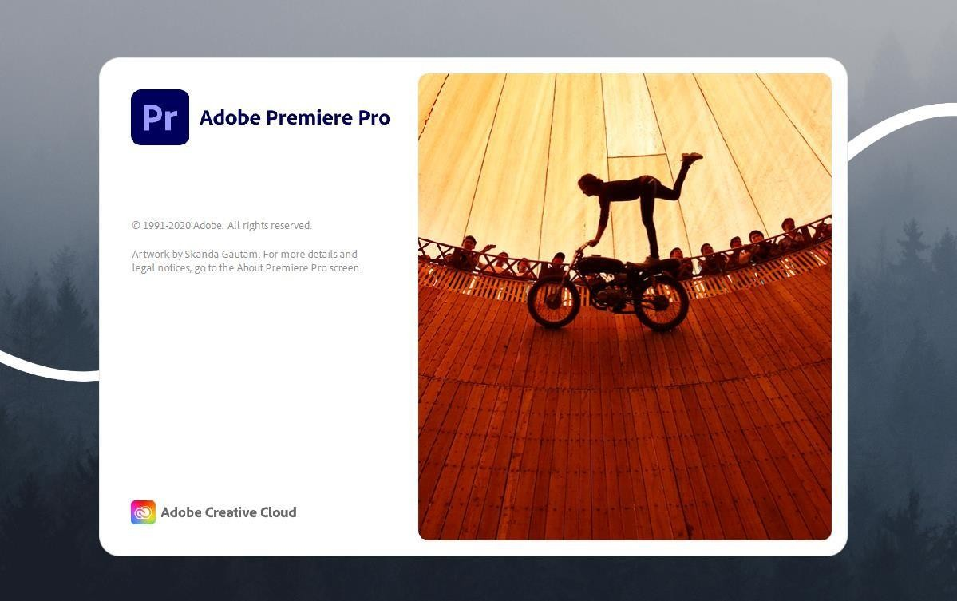

**Export and Delivery:** Export the project in the desired formats and resolutions for distribution, whether for theatrical release, broadcast, streaming platforms, or online channels.

**Quality Control:** Perform quality checks to verify audio-video sync, integrity, closed captions, subtitles, and metadata before delivery.

By meticulously addressing editing, sound design, and finishing touches during the post-production phase, media projects can achieve a professional and polished product that captivates audiences and meets industry standards.

OPEN - PREMIERE PRO

NEW PROJECT AND EDITING – PREMIERE PRO

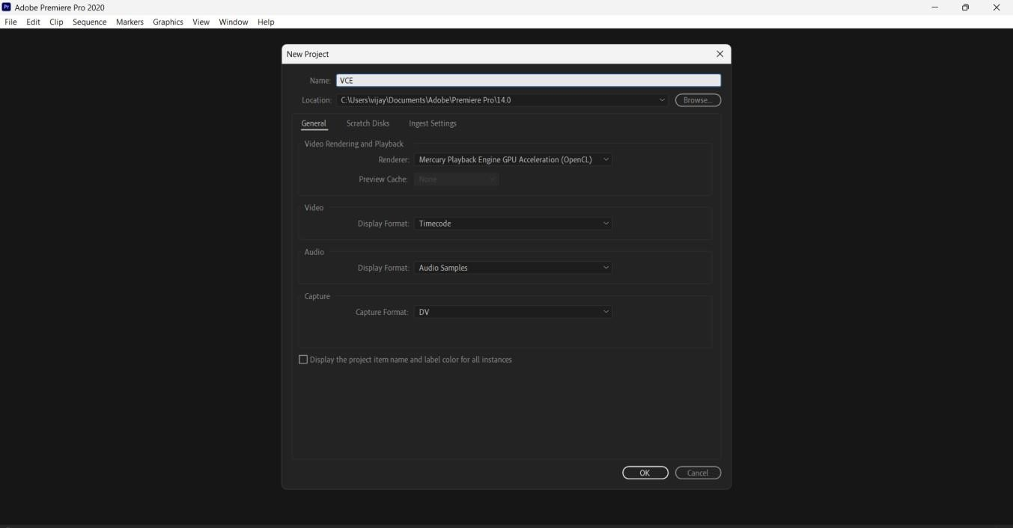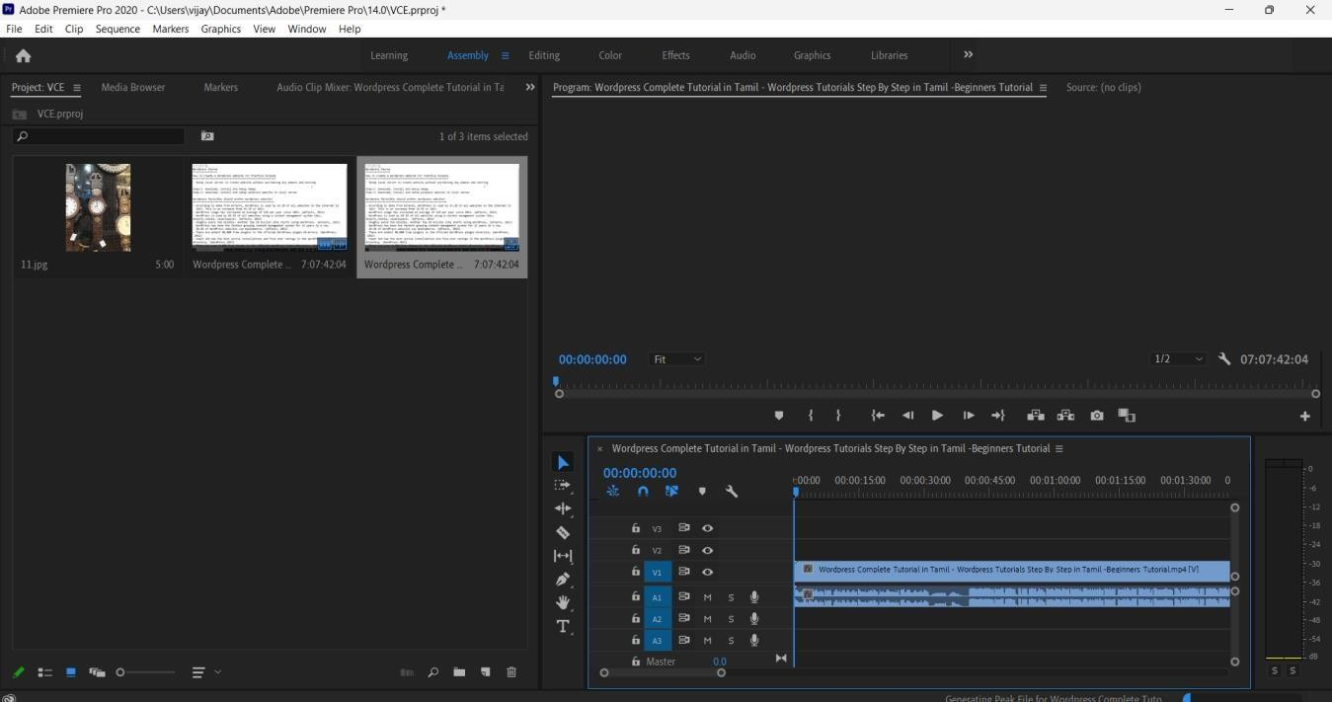

SOUND

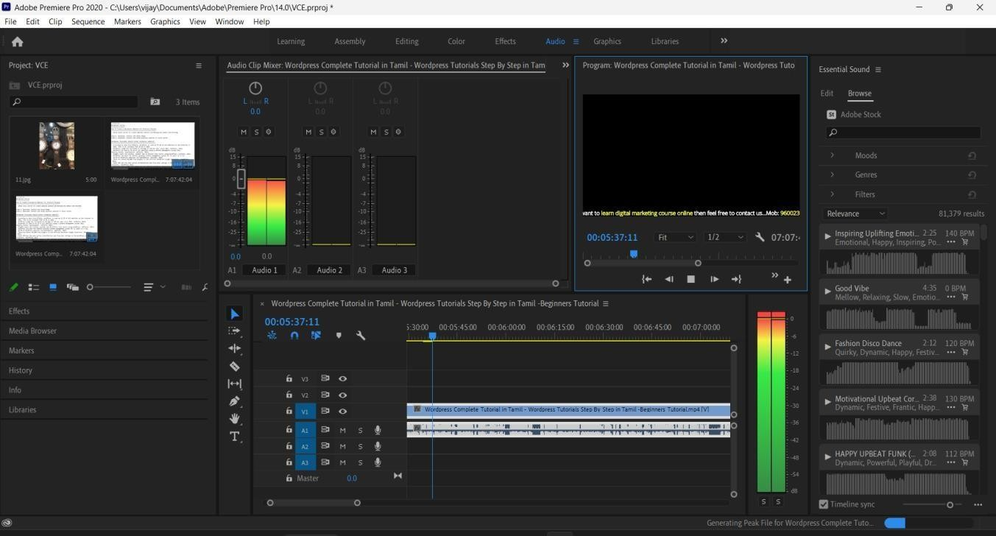

FINISHING

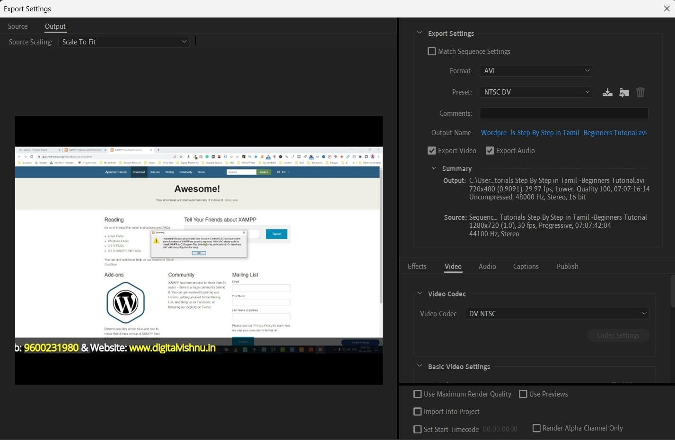

## Result:

Post-production is a crucial phase in media production, where editing, sound design, and finishing touches come together to create a polished and impactful product.